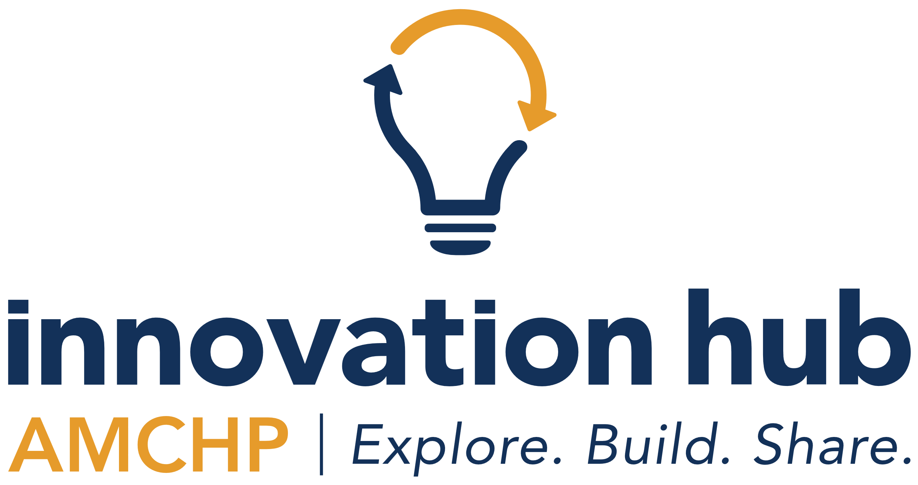

AMCHP Innovation Hub Replication Project

Request for Applications (RFA)

REQUEST FOR APPLICATIONS Released: April 9, 2026
Request for Applications Deadline: June 3, 2026

This request for applications (RFA) includes the following sections:

Selection Criteria | 2
Application Form | 3-4

For questions about this Request for Applications or the Replication Projects, email evidence@amchp.org.

Selection Criteria and Considerations

Reviewers will reflect on notes from your Exploratory Call before reviewing and scoring your application using the following selection criteria and considerations. Please note that AMCHP will prioritize projects submitted by organizations that haven’t been awarded previously, or which feature a practice/policy that haven’t been replicated yet through the Replication Projects. View a list of previously replicated Innovation Hub practices/policies here.

Community Wellbeing
AMCHP’s Innovation Hub encourages those working in maternal and child health to work with thoughtfulness, intentionality, and true consideration of the population they aim to uplift. Achieving community wellness means meaningfully engaging community members in activities that are best aligned with the health goals of the population as well as their unique needs and preferences.
- The applicant describes any of their current/previous work related to improving community wellbeing.
- The applicant describes any existing gaps in quality of or access to care in the proposed project area and explains how replicating the selected practice/policy will contribute to addressing these needs and strengthening their community’s wellbeing.

Partnerships
- The applicant includes a letter of support from the person who will be their practice/policy coach should they be awarded i.e. a representative from the practice/policy selected for replication.
- The applicant describes a clear process for meaningfully engaging community and centering their experience throughout project processes with an emphasis on those who have not historically been engaged in these activities.
- Title V Applications Only: The applicant describes any partnerships with community-based/rooted organizations that are representative of their respective communities.

Replication Project Plan
- The applicant provides a reasonable project plan.

Funding
- The applicant demonstrates a strong need for funding/it appears that funding would greatly impact the success of the project.

Replication Project Team
- The team includes at least one person with personal experience related to the focus of the proposed project.

Shared Decision-Making
- The applicant describes processes and activities that indicate decisions will be made in partnership with partners/community members.

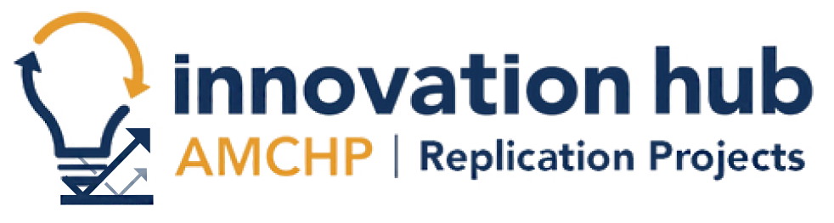

Application

Please provide complete responses to each section below. There are two options for applying, either by providing written responses or by recording a brief video or audio response to each question. For written responses, there is no word limit – please respond to each question fully and with as much detail as you think is helpful. Past applicants have typically written between 1-2 paragraphs per question.

Regardless of the format selected, send your completed application (no more than 5 pages total) to evidence@amchp.org by June 3rd, 2026. You will receive notification that your application has been received no later than two days after you submit along with a brief survey for you to provide feedback on the application process.

Contact Information
Name
Organization
Address
City, State
E-Mail Address

Community Wellbeing

AMCHP’s Innovation Hub encourages those working in maternal and child health to work with thoughtfulness, intentionality, and true consideration of the population they aim to uplift. Achieving community wellness means meaningfully engaging community members in activities that are best aligned with the health goals of the population as well as their unique needs and preferences.
1) Tell us about your organization’s (or partners’) experience with community wellbeing efforts. What work are you/they currently doing? What, if any, are your/their future plans?
Response:

2) How will replicating your selected Innovation Hub practice/policy address existing gaps and strengthen community wellbeing?
Response:

Partnerships
3) Please include a signed copy of your practice/policy coach’s letter of support as a part of your application. You can add it as an attachment with your letter.

☐ Yes, my practice/policy coach’s letter of support is attached.

4) What existing partnerships (especially community partnerships) do you have that will support this project? Please describe each partner.
Response:

5) How will you encourage community and partner engagement and leadership throughout your Replication Project? Be sure to explain how you will engage and support those community members who have historically not been engaged in program activities within their communities.
Response:

6) (Community-rooted/Tribal Entity/Non-Title V Applicants): Describe your current relationship with your state or jurisdiction’s Title V program, if any. Title V is a federal and state partnership that helps women, mothers, infants, children thrive by ensuring access to essential health services. Note: An existing relationship with your state or jurisdiction’s Title V program is not required to participate in this opportunity.
Response:

6a) (Title V Applicants): Does your Title V agency have partnerships with community-rooted organizations that are reflective of their communities? If so, share two examples of these partnerships and describe how they have been important to your work. What have you learned from these partnerships?
Response:

Draft Project Plan
7) What activities will you undertake to implement the Innovation Hub practice/policy you have selected? Please respond to these questions by completing the table below. Please add rows as needed.
- Include activities that will prepare you to implement the practice/policy.
- For each activity listed, indicate:
  - When you anticipate the activity will occur
  - The role of key partners/collaborators
  - What success will look like when the activity is completed

Project Timeline and Breakdown of Activities
Timeframe  (August 2026-  March 2028) | Description of Activity | How will key partners/collaborators be involved in this activity? | What will success look like for this activity?

Replication Project Team
8) Who will be responsible for leading/supporting the plan described above? You may add rows as needed.
Name | Title/  Organization | Role on Project | Email |  | Has personal experience related to the focus of the proposed project?

