Preparing for Sustainability Tool

Preparing for program sustainability involves more than securing ongoing funding. This tool will help prepare public health practitioners to plan for program sustainability by articulating programmatic core values, identifying key domains of sustainability to focus on, defining the current and future state of each of these sustainability domains, and then building a comprehensive sustainability action plan.
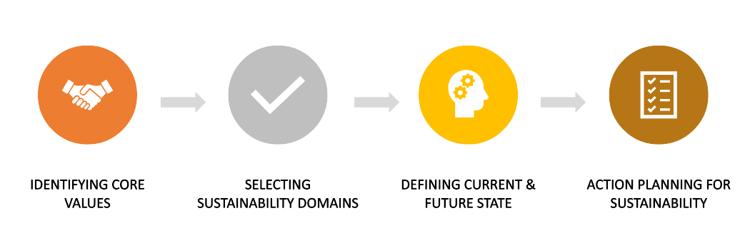
IDENTIFYING CORE VALUES

Core values are the deeply ingrained principles that guide an organization and/or program’s operations. They can be thought of as the internal compass of principles that drives and underpins all activities. When starting to plan for program sustainability or scale up, it is critical to ensure that you have first defined your program’s core values. These values will help guide all future programmatic activities and ensure that all future scale up is authentic to the core tenets of the original practice. Some examples of core values include integrity, clear communication, youth empowerment, accountability, patient driven, racial equity, equal opportunity, prioritizing those with the greatest need, among others.
Use the space below to draft your program’s Core Values:

After drafting the core values, ask yourself the following reflection questions:
- What are examples of what each value looks like in action from our work?
- Are there any core values that we are not currently focused on that we want to better implement? What would it take to do this?
SELECTING SUSTAINABILITY DOMAINS

Once you have identified your core values, next you’ll identify the different domains that you will use to plan for sustainability. Often when we think of sustainability, we focus on funding. While funding sustainability is an important reality, it is just one of many sustainability domains. Thinking holistically about sustainability will help ensure that your program has the infrastructure in place to support continuous growth.

When selecting sustainability domains, you can both create ones tailored specifically to your program as well as use pre-established domains. Some example sustainability domains pulled from various sustainability frameworks and tools (see additional resources to learn more) include:
- Quality Improvement and Evaluation
- Funding Stability
- Partnerships
- Outreach and Recruitment
- Supplies and Resources
- Organizational Capacity (including staff and processes)
- Program Adaptation
- Strategic Planning
- Communications
- Environmental Support (including leadership and public)

Aim to generate and select between 5-9 domains to keep the subsequent sustainability action planning process streamlined and feasible.

Use the space below to identify your Sustainability Domains:

DEFINING CURRENT & FUTURE STATE VALUES

For each of the domains that you identify, you will first define what the “Current State” is for that category. This is what your work looks like currently related to this domain, including both strengths and areas for growth. For example, what does your practice’s outreach currently look like? More specifically, what kind of activities and resources do you dedicate to your outreach strategy, if any? Once you define the “Current State” for a domain, you will then go on to define the “Future State” that you would like to see for this domain in one year and in five years. For example, in one year from now you might want your program to begin conducting outreach in new school districts. In five years, you might hope that you will not have to do targeted outreach because school districts know of your program and reach out to you directly to express their interest.

For each domain listed above, complete the following table to define the Current and Future States (Note, this activity call also be done in Jamboard):

Sustainability Domain Name:
Current State |  | Future State (One Year) | Future State (Five Years)
Strength Areas | Areas for Growth

After completing the tables above, ask yourself the following reflection questions:
- Which of the sustainability domains should we prioritize to best achieve the Future State we would like to see in one year? Consider which domains you noted that are strengths – how might you continue to support and maintain these efforts? For those domains where you indicated you have more work to do to put them in place and/or strengthen them, where are their opportunities to leverage your areas of strength to do so? Note: you will begin the action planning below with the domains that you prioritize in response to this question.
- Are there any themes or trends we are seeing?

ACTION PLANNING FOR SUSTAINABILITY

After mapping out the Current State and desired Future States for your various sustainability domains, it is time to begin planning out how you will achieve these desired states. You can do this by completing the action planning table below.

Complete the following table for each of your sustainability domains, beginning with the domains that you identified as priority domains to achieve your desired One Year Future State:

Sustainability Domain Name:
Work/Activity | Intended Product/ Measurable Outcome | Resources needed to sustain, strengthen, or develop this work? | Timeline | Person Responsible

ADDITIONAL RESOURCES & NEXT STEPS

Remember, planning for sustainability is an iterative and ongoing process rather than an outcome. To ensure that you are continually planning for sustainability throughout program implementation, it is important to periodically reflect on and assess where you are in relation to your desired one-year and five-year “Future State” for each of your sustainability domains to help guide your work. This document and other planning documents should be viewed as “living” documents and be frequently revisited as a part of strategic planning efforts.

Below are additional resources to help you further plan for program sustainability:
- The Program Sustainability Assessment Tool (PSAT) is a self-assessment used by both program staff and stakeholders to evaluate the sustainability capacity of a program. When you take the assessment online, you will receive a summary report of your overall sustainability, which can be used to help with sustainability planning.
- The Georgia Health Policy Center’s Sustainability Framework identifies the components that contribute to organizational and programmatic sustainability, and explores funding diversification considerations.

