Building Your Evaluation Plan

When developing an evaluation plan, you want to begin by creating an aim statement, logic model, and evaluation questions. This guide will help you flush out the components of your own evaluation plan by drafting each of these pieces.
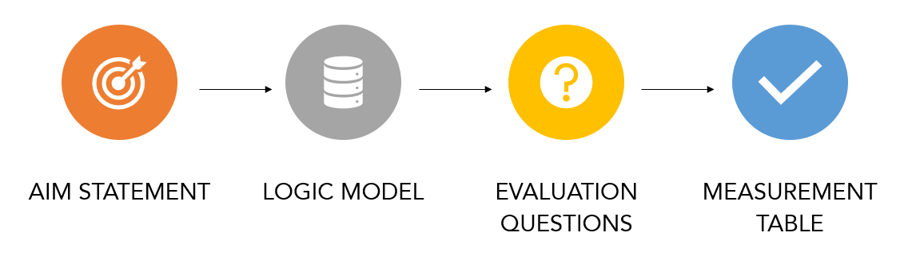
AIM STATEMENT

AIM STATEMENT: An aim statement is a clear, explicit summary of what you hope to achieve over a specific amount of time including the magnitude of change you will achieve. The aim statement guides your work by establishing what success looks like. It states the areas in which the program will work toward the vision, but it does not list all activities that the program will engage.
AIM STATEMENT TEMPLATE: We aim to (ACCOMPLISH WHAT) because (WHY IT IS IMPORTANT) with/for (THE POPULATION YOUR PROGRAM SEEKS TO IMPACT) by (TIME-FRAME FOR THE PROJECT).
Check out this video to learn more.

Draft your Aim Statement in the table below:
Aim Statement

LOGIC MODEL

LOGIC MODELS: An effective logic model makes an explicit, often visual, statement of what is needed (resources, actions, relationships) to bring about change and how one changes influences another in an effort to contribute to a community or population-level outcome. Logic models serve as a road map or your mental model. Once you have an idea of where you want to go, you need a plan to get there to keep your team moving forward.
It is important to note that logic models, like any tool, are only as good as the thinking put into them and the commitment to their ongoing use. If you ignore nuance, you won’t set yourselves up to learn about why things are or are not working as planned. A logic model will put that thinking onto paper so you can turn it into a plan.
TO BEGIN: There are two ways to approach creating a logic model. One uses forward logic and the other uses reverse logic
1. Forward logic - Moving forward from the activities. This approach explores the rationale for activities that are proposed or currently under way
2. Reverse logic - Moving backward from the effects. This approach begins with the end in mind. It starts with a clearly identified value, a change that you and your colleagues would definitely like to see occur
Check out this video to learn more.

Draft your Logic Model in the table below:
Inputs | Activities | Outputs | Outcomes
The resources for your program | What you do with the resources | The direct products of your activities | Short-term  Changes in learning | Intermediate  Changes in action
 |  |  | Long-Term (Impacts)
 |  |  | Changes in conditions

EVALUATION QUESTIONS

Evaluation questions help further focus your evaluation and should reflect the purpose of the evaluation as well as the priorities and needs of the stakeholders. You should develop questions you want the evaluation to answer about the program component/activity you are interested in evaluating.
Steps for Drafting Evaluation Questions:
- Involve KEY partners and review your logic model
- Review with stakeholders why you need to do the evaluation and how the results will be used and by whom. Verify that the evaluation can be conducted with the available resources (e.g. funds, staff). Then, review the logic model you created to identify your key activities, the respective process, and outcome components associated with those key activities to generate relevant questions.
- Brainstorm evaluation questions - “What are the questions we want the evaluation to answer?”
- Classify your questions by theme
  - Process: Inputs, Activities, Outputs
  - Outcome: Short, Intermediate, and Long-term outcomes
- Prioritize evaluation questions - Narrow down the number of proposed evaluation questions depending on the relevance of the question to the purpose of the evaluation.
  - Ask yourself: “Why this question?”
Check out this video to learn more.

Draft your Evaluation Questions in the table below. Once you have drafted your evaluation questions, you can then prioritize the evaluation questions to narrow down the number of questions you will include in your evaluation. Bold each of the questions that you will be prioritizing.
Evaluation Questions

MEASUREMENT TABLES

Measurement tables can be used to track what indicators and measures you are going to use to answer your evaluation questions. These can also be used to further flesh out ideas for measuring each activity described in the logic model.

Check out this video to learn more.

See the example measurement table below:
Outcome/Evaluation Question: Community members feel engaged/like their voice was heard in the development of the practice
Performance Measure: | % of community members who completed the evaluation survey who feel like they were engaged and/or like their voice was heard throughout the revitalization project
Target: | 90% of community members surveyed felt like they were engaged and/or like their voice was heard throughout the revitalization project
Data Source: | Evaluation survey data  Administrative data
Indicators [List below] |  | Data Source
# of community members in the Community Advisory Group of the Community Revitalization team |  | Administrative Data
# of community members who completed the initial input survey conducted by the community engagement professional/organizer |  | Administrative Data
# of community members who completed an initial focus groups or key informant interviews conducted by the community engagement professional/organizer |  | Administrative Data
% of community members who answered the evaluation survey question “I felt like my voice was heard throughout the revitalization project” with “Agree or Strongly Agree” |  | Survey Data
% of community members who answered the evaluation survey question “I felt like there were enough opportunities for me to engage with the revitalization project” with “Agree or Strongly Agree” |  | Survey Data

For each of the key outcomes and evaluation questions that you are interested in answering, draft a measurement table using the templates below:
Outcome/Evaluation Question:
Performance Measure:
Target:
Data Source:
Indicators [List below] |  | Data Source

Output / Outcome ​ | Indicator/ Measure ​ | Method ​ | Data Source ​ | Frequency ​ | Responsibility ​ | Status ​  C=complete ​  P=In progress ​
List any additional considerations or information you need to know. ​
​

