Developing Key Performance Indicators Tool
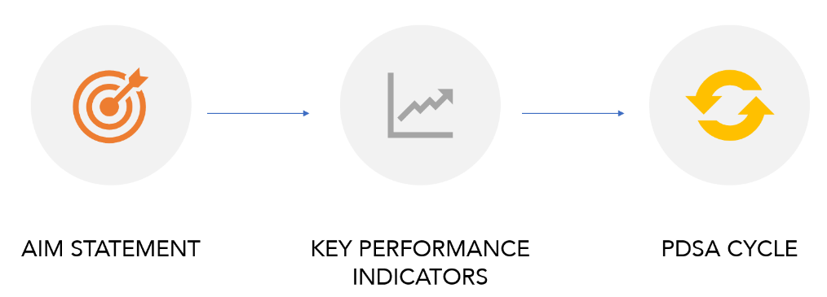
This tool details the process of developing key performance indicators (KPIs) to help your organization track progress towards your strategic goals. The tool walks through the process of creating am aim statement to articulate your overall organizational goals, drafting KPIs and building out a KPI tree, and using plan-study-do-act (PDSA) cycles to make small incremental tests of change. The case study at the end of the tool provides a descriptive example of what using each of these tools looks like in action.
AIM STATEMENT

An aim statement is a clear, explicit summary of what you hope to achieve over a given time and the reason why that change is important. The aim statement guides your work by establishing what success looks like for your initiative. It states the areas in which the program will work toward the vision, but it does not list all activities that the program will engage. Your aim statement is the “north star” of your project, the overall vision that you can return to throughout the implementation of your work to ensure that you are on track to achieve your desired change.
AIM STATEMENT TEMPLATE:
We aim to (WHAT ARE YOU TRYING TO ACCOMPLISH?) because (WHY IT IS IMPORTANT?) with/for (WHO IS THE PRIORITY POPULATION YOUR PROGRAM SEEKS TO IMPACT?) by (WHAT IS THE TIME-FRAME FOR THE PROJECT?).
Example: We aim to increase the percentage of adolescents in our jurisdiction who receive an annual adolescent well-visit because all adolescents deserve to be able to access critical preventative care regardless of their race or socioeconomic status. To do this, we will partner with 5 priority school districts who serve the target adolescent population to implement strategies by the end of the 2023-24 school year.

Check out this video to learn more about drafting an aim statement.
Draft your Aim Statement in the table below:
Aim Statement
We aim to _______ because __________ with ________ by ________.​

KEY PERFORMANCE INDICATORS & CRITICAL SUCCESS FACTORS

While Aim Statements can help you define what success looks like at a higher level, key performance indicators can help you track progress towards specific strategic goals.

Key performance indicators (KPIs) are qualifiable measures of performance over time for a specific objective. Typically, KPIs are tied to a larger strategic organizational goal. For example, if you work for your state’s maternal and child health bureau and one for your strategic goals this year is to increase your coordination with your state’s Medicaid office, a KPIs for this goal might be the number of Medicaid referrals coming into your agency. ​Just like there are process and outcome focused evaluations, there are also process oriented and results/outcome oriented KPIs.

A good KPI should be realistic, straightforward, and easy to measure. A KPI should be:
- Aligned: A KPI should be with the overall organizational strategy and outcomes. The overarching aims and goals should be what informs your KPIs.
- Actionable: Once you’ve set your KPI, you need to outline the steps you’ll take to reach it and the metrics you’ll measure along the way.
- Realistic: Start small. Big, lofty KPIs—while they might look good on paper—aren’t doing you or your team any favors if they’re unrealistic from the get-go.
- Measurable: When you set KPIs, ask yourself: What are you trying to achieve? What is the desired result? What’s the timeline? Remember to add: How am I going to measure my KPIs?
Before you develop your KPIs, you will first want to identify your critical success factors. While a KPI measures your effectiveness at achieving a strategic goal, a critical success factor (CSF) is the process that you need in order to achieve your strategy. Critical success factors are the elements necessary for a strategy to be successful.

Critical success factors + Key performance indicators = Successful strategy
    - CSF: Process/Elements needed to achieve goal/activity
    - KPI: Measures if the CSF conditions are being met

To help clarify the relationships between CSFs, KPIs, and data, check out the example below:
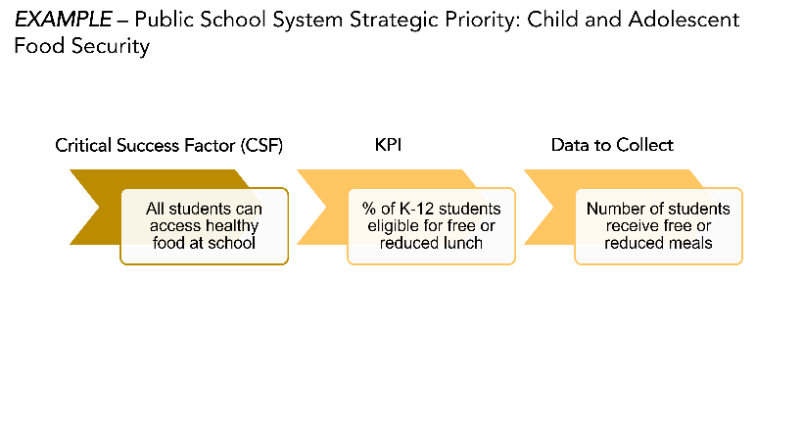

Use the table below to draft your respective CSFs, KPIs, and any relevant data to be collected:

Critical Success Factor (CSF) | Key Performance Indicator (KPI) | Data to Collect

KEY PERFORMANCE INDICATOR (KPI) TREE

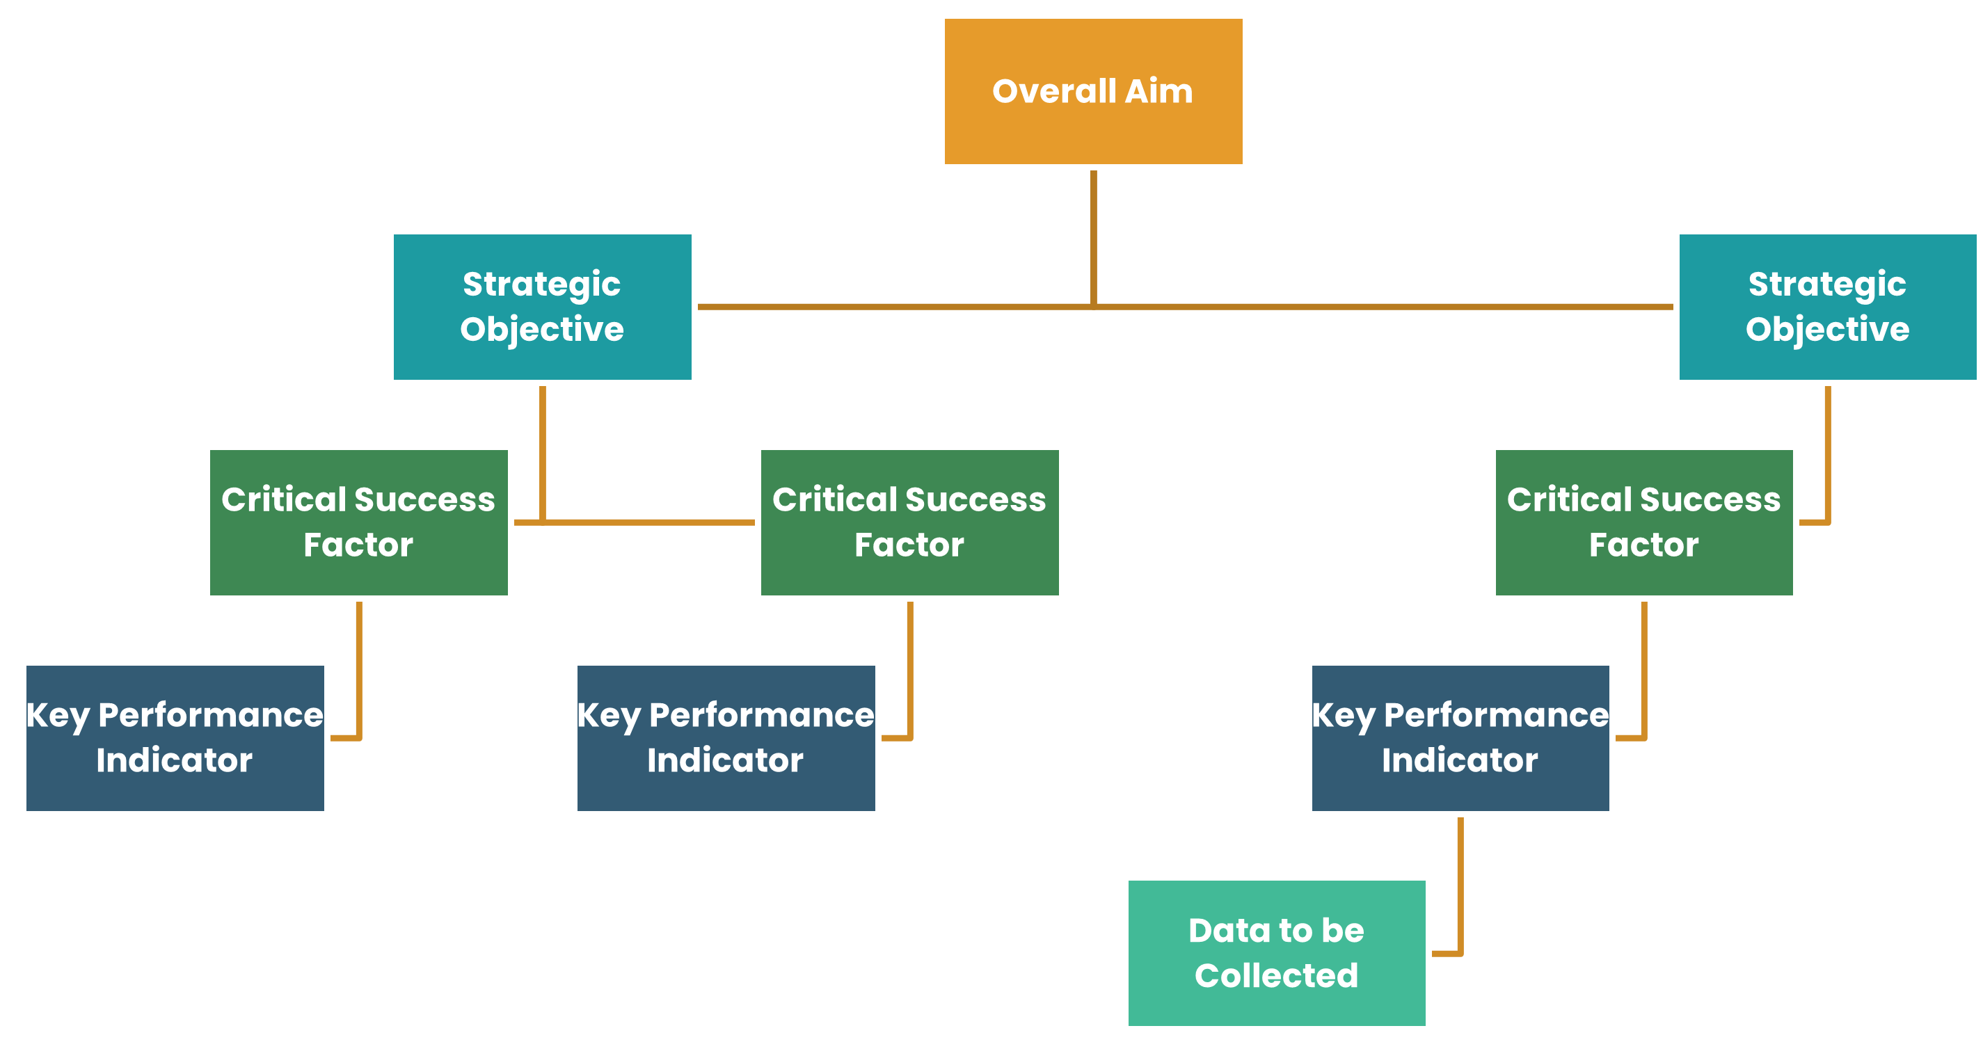

A KPI Tree is a visualization method that allows an organization’s objectives to be broken down into granular desired objectives and relevant CSFs and KPIs. This visualization method can display a range of measures in an organization or related to a project. They allow you to visualize complex relationships and interdependencies within an organization, as well as the relationship between key performance indicators and critical success factors.

You can use a KPI Tree to help your organization:
- Breakdown objectives into granular outcomes and relevant KPIs or metrics
- Visualize relationships, conflicts, and interdependencies within organizational structure.

A KPI Tree can be a helpful way to bring together your aim statement, critical success factors, KPIs, and any data that you will need to collect for each KPI.

Use the blank KPI tree template on the next page to map out the CSFs, KPIs, and data to collect that you brainstormed in the table in the previous section.

PLAN DO STUDY ACT (PDSA) CYCLES

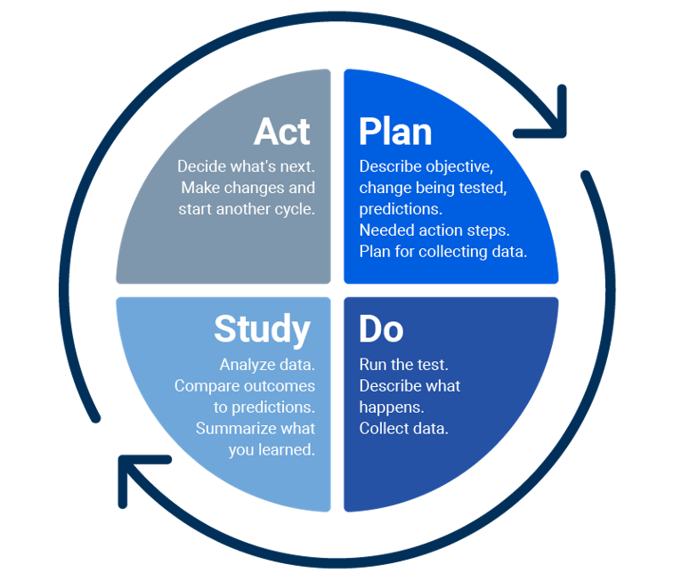
A Plan-Do-Study-Act (PDSA) Cycle is a basic quality improvement process that allows an organization to test and analyze a change on a small scale to determine whether it is improving a process or making it more efficient.
The PDSA framework covers four phases. It allows organizations to plan to test a change in a process (plan), to carry out that test by making changes in that process (do), to observe and analyze, through measurements, the effects of that change (study), and then to decide how to react to that first test (act).

When and Why should you used PDSA Cycles?
PDSA Cycles:
- Support us in moving from initial to full implementation, and in conducting quality improvement initiatives;
- Provides a structured experimental learning approach to testing changes;
- Allow us to learn as quickly as possible if/how an intervention works in a particular setting;
- Allows us to adjust accordingly to increase chances of delivering and sustaining the desired improvement, or to stop the intervention and try something else.

Complete the blank PDSA cycle below to practice testing a small change to your organizational practice:
Plan
Do
Study
Act
INSERT TEXT HERE
INSERT TEXT HERE

INSERT TEXT HERE
INSERT TEXT HERE
CASE STUDY: Adolescents Well-Visits

The following case study services as a comprehensive example of what it looks like in practice to apply each of the three methods presented in this tool in practice.
CASE STUDY SCENARIO:
You are the Adolescent Health Coordinator tasked with identifying strategies to increase the number of adolescents in your jurisdiction who receive an annual adolescent well-visit. Specifically, your strategies should target disparities in accessing a well-visit by race and socioeconomic status among adolescents. You have identified five priority school districts with the lowest prevalence of students receiving an adolescent well-visit and will be working with these districts for the upcoming year.

AIM STATEMENT:

- We aim to increase the percentage of adolescents in our jurisdiction who receive an annual adolescent well-visit because all adolescents deserve to be able to access critical preventative care regardless of their race or socioeconomic status. To do this, we will partner with 5 priority school districts who serve the target adolescent population to implement strategies by the end of the 2023-24 school year.

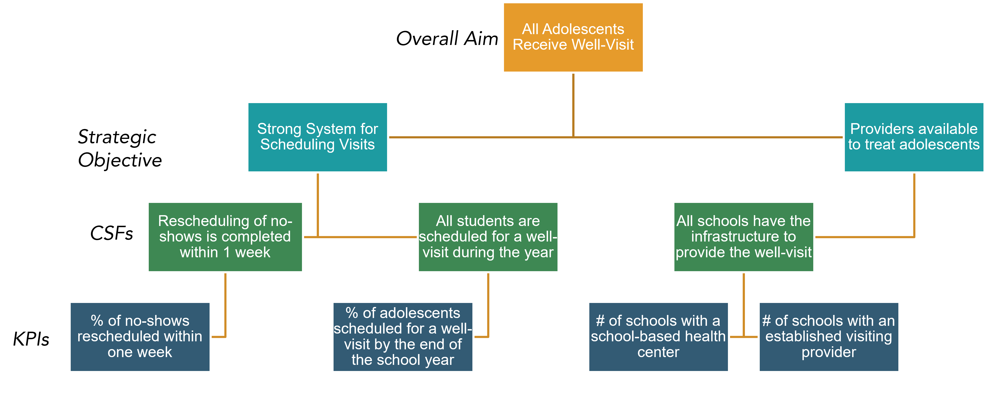
KPI TREE:

PDSA CYCLE:
The coordinator realizes that not all no-shows are being rescheduled for their wellness-visit within 1 week and decides to test out the following solution using the PDSA Cycle below.
- Proposed Solution: Collaborate and distribute “no-show” call logs with two staff members on the team to increase reach
Step 1: Plan
Step 2: Do
Step 3: Study
Step 4: Act
Create plan to divide follow-up calls for adolescents that need to be rescheduled among two additional staff members
You realize collaborating with additional staff did not solve the problem, and will need to find ways to reschedule adolescent well-visits besides phone calls
Evaluate if all staff completed their calls and rescheduled well-visits; Look to see how % of no-shows rescheduled in less than a week changed
Staff conduct follow up calls with adolescents that need to be rescheduled

ADDITIONAL RESOURCES

Innovation Hub Learning Community February 2023 Training Webinar – Tracking Progress Towards Your Goals: Utilizing Key Performance Indicators
- AMCHP's Evidence & Implementation team introduces the basic concepts of key performance indicators (KPIs), their relationship to strategic goals, and discusses how tools such as PDSA Cycles, Aim Statements, and KPI Trees can be used to track organizational or programmatic progress towards strategic goals.
- Access the recording here.

