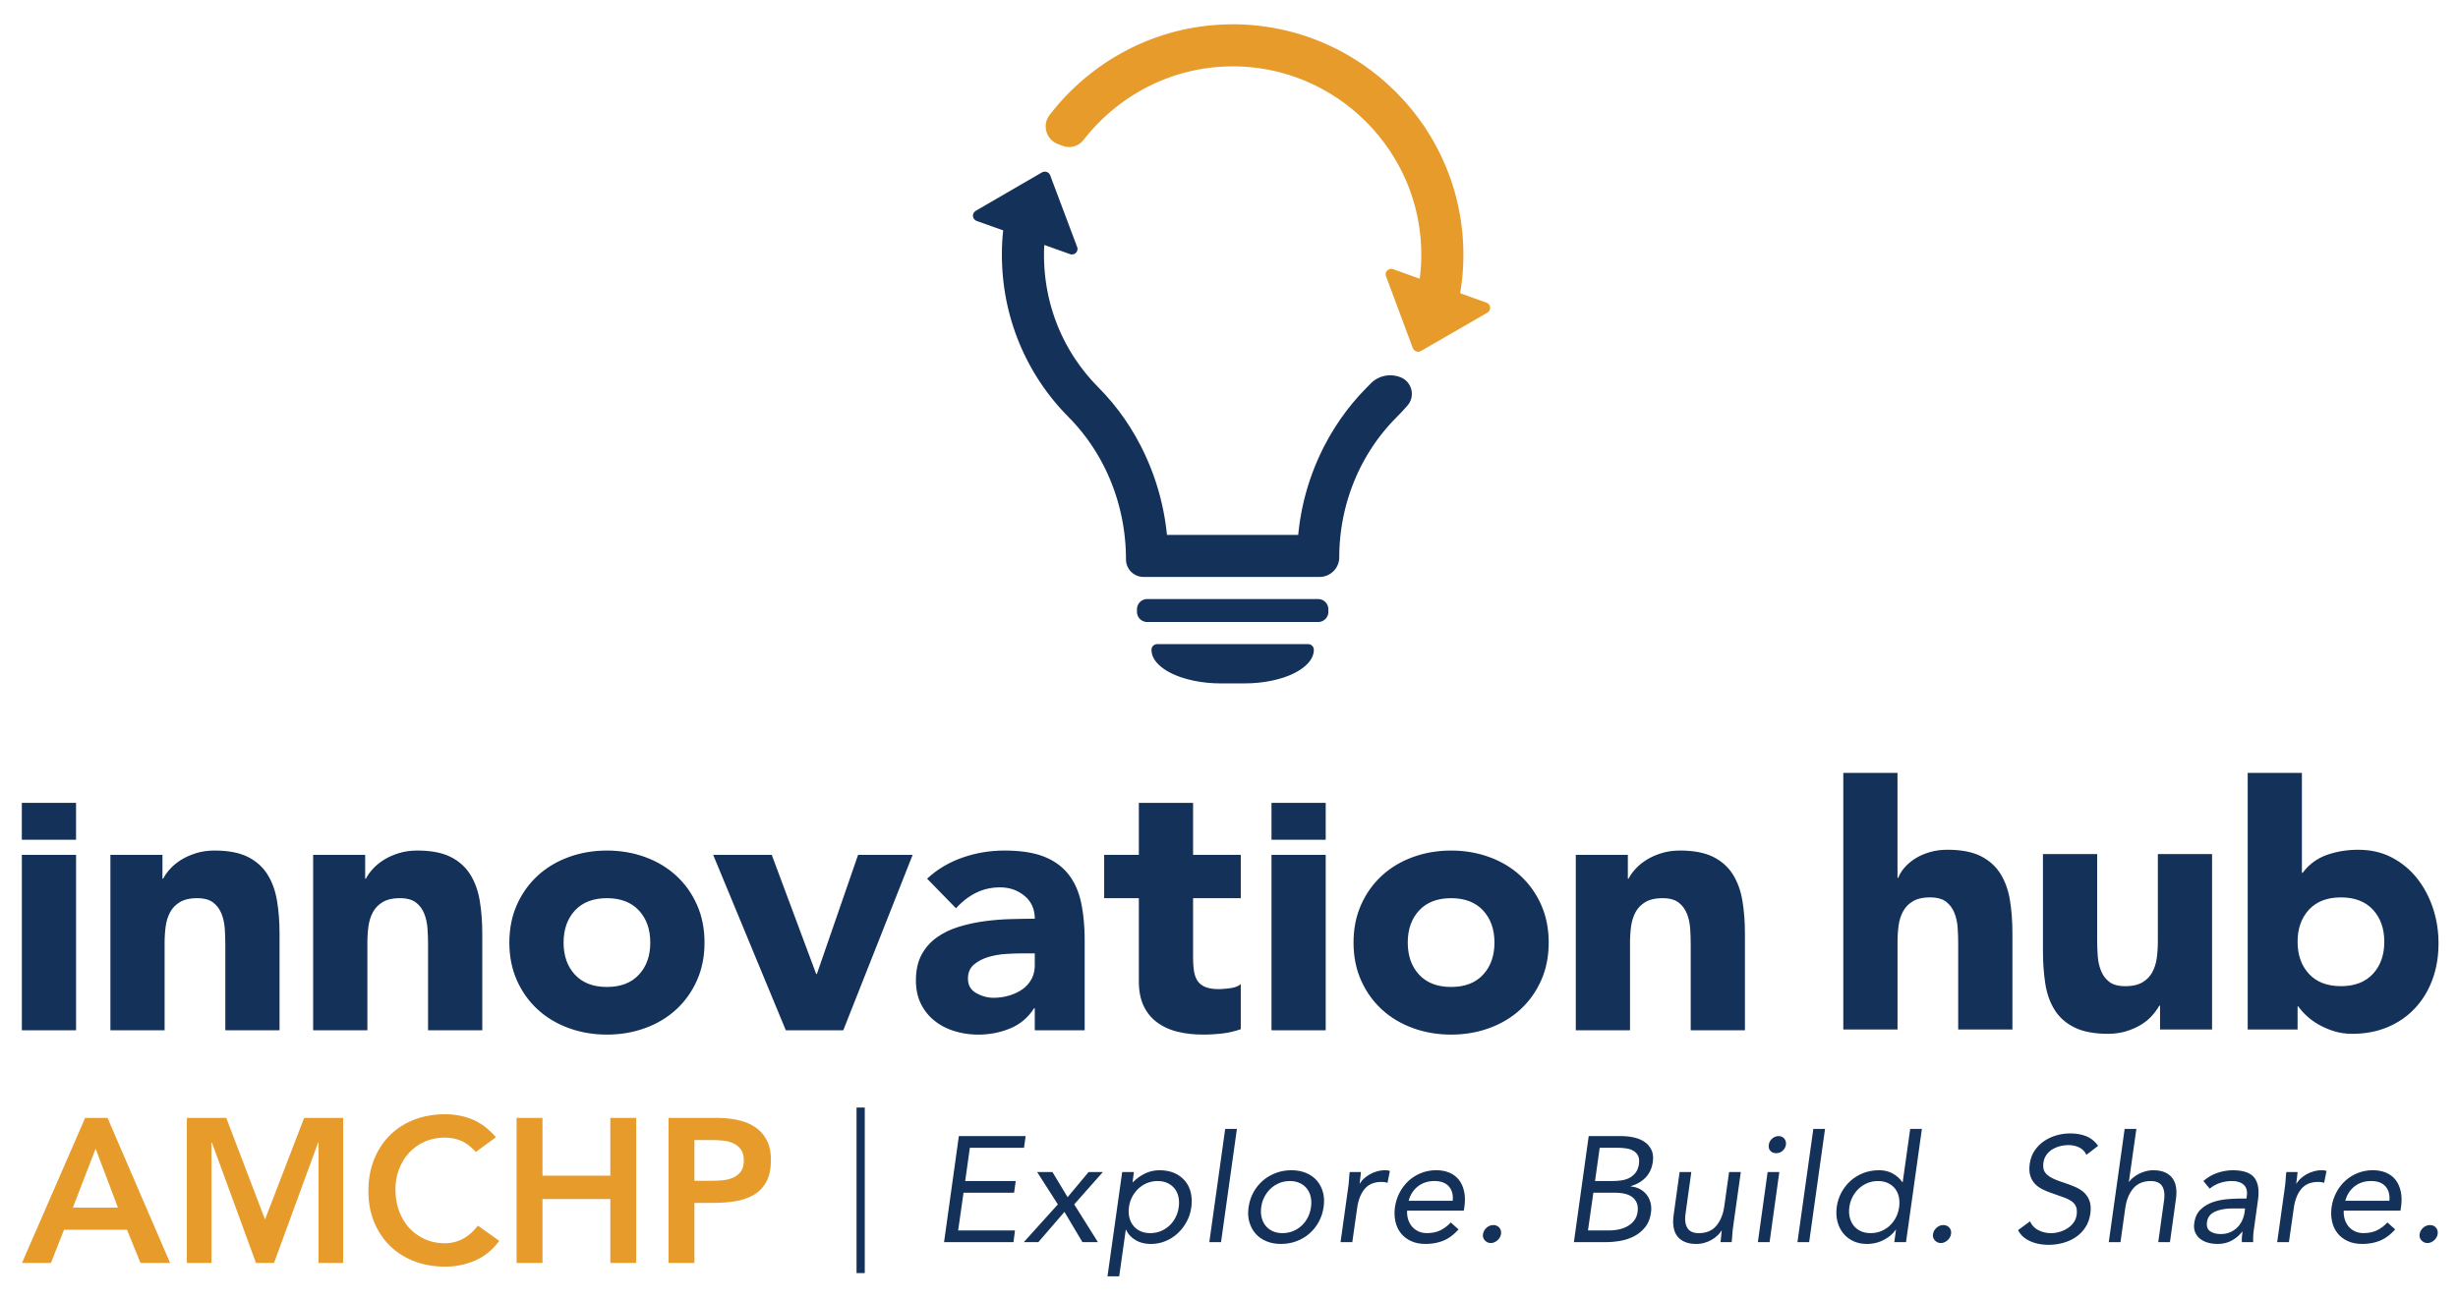

Replication Project: Capacity Building Track

Request for Applications (RFA)

REQUEST FOR APPLICATIONS Released: January 2022
Request for Applications Deadline: March 2022

This request for applications (RFA) includes the following sections:

Replication Project: Capacity Building Track Overview | 2-4
Selection Criteria | 4-5
Application Process | 5
Application Form | 6-7

Application Timeline (Subject to Change)

For questions about this Request for Applications or the Replication Projects, email evidence@amchp.org.
Replication Project: Capacity Building Track Overview
This RFA is for the Replication Project: Capacity Building Track. This track is designed for organizations who have selected an Innovation Hub practice to implement but need support developing and/or strengthening infrastructure and capacity necessary to replicate it. Specifically, this track will support you to answer the following capacity building focused questions by providing you with relevant tools, resources, and technical assistance:
- Have you identified what resources you will need to replicate the selected practice?
  - Do you have all or most of the resources you identified?
- Do you have a team dedicated to supporting the replication of this practice?
- Do you have a plan for assessing progress towards replicating this practice?
- Do you have a way to assess how involved community members/partners are in replicating the practice?
- What changes might your organization need to make to its trainings, processes, policies, or activities to replicate this practice?
Who Can Apply?

This opportunity is open to all organizations or agencies interested in replicating an Innovation Hub practice. This includes, and is not limited to, community-rooted organizations, non-profit organizations, academic institutions, and state and local public health agencies.

Title V programs interested in this technical assistance (TA) opportunity are required to partner with a community-rooted organization(s) that is already engaged in the work that would be addressed through the Replication Project. Non-Title V programs interested in this TA opportunity are strongly encouraged to partner with their state/jurisdictional health department and/or community-rooted organizations that are already engaged in work that would be addressed through the Replication Project. Please contact AMCHP (evidence@amchp.org) if you would like support to do this.

Note: In alignment with AMCHP’s “Joint Organizational Commitment to Anti-Racism and Racial Equity” statement we will be prioritizing projects led by or directly supporting Black Indigenous People of Color (BIPOC); others experiencing systemic oppression; or those representing groups that have been historically oppressed.

Project Funding

The Capacity Building Track provides up to two awardees per year with up to $15,000 to prepare to implement a selected Innovation Hub practice. These funds can be used in a variety of ways. Below are examples of how previous recipients have used funds:

Travel to/from the organization whose practice you are replicating to learn more about their work | Consultant fees to develop reports, conduct meetings/focus groups, etc.
Web development and support services | Project or training materials
Professional printing | Incentives such as parent/youth/community/ volunteer stipends
Meeting or trainer associated costs | Project dissemination/educational materials
Note: Funding is meant to assist in initiating the replication of a practice or to supplement existing work being done to replicate the practice. Applicants are encouraged to consider the sustainability of replicating a practice and identify other sources of funding to contribute to this. In addition, while replication funds can be used in several ways, they cannot be used to pay for equipment, software, conference or course registration, or personnel expenses including staff FTE (Full-Time Equivalent). As noted in the application below, if awarded you will be asked to provide a detailed budget indicating how you will use the funds.

Benefits – What’s in It for You?

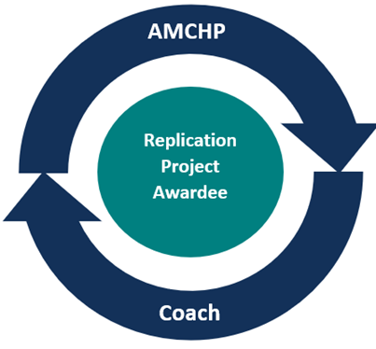
Once awarded, you will receive replication support from a representative of the Innovation Hub practice you’re replicating as well as logistical and training support from AMCHP.

From a representative of the Innovation Hub practice being replicated, you’ll receive:
- Insight into the development and implementation of the practice being replicated
- Guidance on ways to adapt or modify the practice to your context
- Check-ins to support replication of the practice

From AMCHP, you will receive:
- Logistical support including developing a contract, processing invoices/ reimbursements, initial connection to a representative of the practice being replicated, agenda/meeting development, etc.
- Facilitated check-in calls to plan/coordinate/guide TA
- Information and resources about best practices and Innovation Hub
- Support to facilitate peer relationships between you and the Innovation Hub practice representative
- Facilitated quarterly trainings/webinars with other awardees
- Relevant tools and resources to move your project forward

Note: Even if your application is not awarded, you are still eligible to receive technical assistance and attend all training webinars if interested.

What Will You Walk Away from This Opportunity With?
- Increased visibility of your work
- Learned about challenges, lessons learned, and useful datapoints for measuring success from a peer state/territory/organization that has already implemented the practice you’re replicating
- Received TA and support from national and state experts
- Built meaningful relationships with key partners, including family and community partners, individuals with lived experience, and direct service providers
- Developed a plan for project sustainability
- Increased knowledge of implementation tools and processes
- Shared your thoughts on your TA experience and suggestions for improvement via a final report and 6 month-follow up report
- A write up of your experiences and key insights published in AMCHP’s bimonthly newsletter, Pulse, as well as being featured on AMCHP’s Innovation Hub
Commitment – What to Expect

If awarded, you will be asked to commit to:
- Identifying at least two team members to represent your organization in webinars, check-ins, and communication with AMCHP. This includes ensuring that at least one team member is someone with lived experience related to the focus of your project.
- Co-developing a coaching scope of work with your assigned coach.
- Attending all required virtual meetings and trainings to the best of your ability.
- Being responsive to AMCHP communications about the project.
- Participating in regular check-ins with AMCHP staff (at least quarterly).
- Documenting project expenses and sending in invoices in a timely manner.

In addition, you will be asked to contribute to the following areas:

Reporting and Evaluation
Awardees are required to report on the outcomes of the Replication Project. The final report must include a summary of TA activities, results/action steps determined, and progress made toward replication. Awardees will also be contacted six months after completion of the project to complete a six-month follow-up report to elaborate on any successes, challenges, or changes made to the Replication Project following the completion of formal TA.

Sharing Your Experiences
To capture the value of the connections fostered during the replication project, awardees will write a brief article for AMCHP’s bi-monthly newsletter, Pulse. The contents of the article will include experiences, challenges, and lessons learned from practice replication and implementation. In addition, awardees may also be asked to share their experiences with others via webinar. Recipients may also be asked to provide a brief write-up of their project for inclusion in the MCH Innovations Database.

Sustaining Knowledge
To further support implementation and adaptation of practices in Innovation Hub, AMCHP will continue to develop tools and resources designed to assist U.S. jurisdictions to translate strategies into action steps. AMCHP may reach out to former awardees as thought leaders during resource development to foster increased peer-to-peer learning and improve practicality of tools such as AMCHP’s MCH Innovations Database and Implementation Toolkits.

Selection Criteria/Considerations

Reviewers will first review your responses to the Readiness Assessment Call before reviewing and scoring your application using the following selection considerations/criteria.
Health Equity
- The applicant describes any health inequities in the proposed project area and explains how replicating the practice will contribute to reducing health inequities.
- The applicant describes any experience with health equity-related work.
- Title V Applications Only: The applicant indicates their level of familiarity with racial equity and any current work they are doing around this.

Partnerships
- The applicant describes any project partners and provides letters of support.
- The applicant describes a clear process for meaningfully engaging community leaders and centering their experience throughout project processes.
- Title V Applications Only: The applicant describes any partnerships with community-based rooted organizations led by and serving Black, Indigenous, Hispanic/Latinx, Asian, Pacific Islander, and other communities of color.

Replication Project Plan
- The applicant provides a reasonable project plan.

Note: In alignment with AMCHP’s “Joint Organizational Commitment to Anti-Racism and Racial Equity” statement, we will be prioritizing projects led by or directly supporting Black, Indigenous, People of Color (BIPOC); others experiencing systemic oppression; or those representing groups that have been historically oppressed.

Application Process

The application process for the Replication Projects consists of three steps:

Step 1: Reflect on the Readiness Statements on the AMCHP website and sign up for a Readiness
Assessment Call
- The first step in the application process is to review the series of readiness statements and participation criteria on the AMCHP website and determine your eligibility for the opportunity.
- If you feel sufficiently ready to proceed after reflecting on these, use this link to sign up for a Readiness Assessment Call with AMCHP staff.

Step 2: Participate in a Readiness Assessment Call
- During the call, you will be asked a series of questions to help determine if you’re ready to apply, and if so, which Replication Project track (Capacity Building or Implementation) is the best fit for you. AMCHP staff will also offer suggestions/ideas for developing your application based on any sections/areas you may want to strengthen. Again, you can sign up for the phone assessment using this link and you will find the assessment questions on our website. You are welcome to invite others to participate in the call.
Step 3: Complete the Application for the Relevant Track
- After the phone interview, you will receive a copy of the appropriate application form. For anyone who is not ready to apply based on the discussion, you will receive suggestions on additional
resources to support your next steps.
You should complete all sections of your respective application form and are strongly encouraged to contact the Innovation Hub practice you would like to replicate to get additional information about the practice
before applying. Contact information can be found by searching for the practice in the MCH Innovations Database or by emailing evidence@amchp.org.

Capacity Building Track – Application

Please provide complete responses to each section of the application below. There are two options for applying, either by providing written responses in the form below or by recording a brief video or audio response to the questions. Regardless of the format selected, please send your completed application to evidence@amchp.org by March 28th, 2022. You will receive notification that your application has been received no later than two days after you submit. If you have any questions while completing the application form, reach out to evidence@amchp.org.

Contact Information
Name
Organization
Address
City, State, ZIP
Phone
E-Mail Address

How did you find out about this opportunity?
☐ AMCHP Website  ☐ AMCHP Staff Person  ☐ AMCHP Social Media (Facebook, Twitter)  ☐ AMCHP Member Briefs/Regional Updates | ☐ AMCHP Pulse Issue  ☐ Shared by someone outside of AMCHP (please specify: ____________________________)  ☐ Other (please specify):

Health Equity
The Robert Wood Johnson Foundation defines health equity as "… everyone has a fair and just opportunity to be as healthy as possible. This requires removing obstacles to health such as poverty, discrimination, and their consequences, including powerlessness and lack of access to good jobs with fair pay, quality education and housing, safe environments, and health care."
1) Tell us about your organization’s (or partners’) experience with health equity work. What work are you/they currently doing? What, if any, are your/their future plans?
Response:
2) How will replicating your selected Innovation Hub practice contribute to reducing health inequities among historically and systemically oppressed groups?
Response:
2a) (For Title V Applicants Only): Describe your Title V program’s familiarity with racial equity and any current work to be anti-racist in your programs and services.
Response:

Partnerships
3) What existing partnerships (especially community partnerships) do you have that will support this project? Please describe each partner and attach at least one letter of support when you submit your application.
Response:
4) How will you encourage community and partner engagement and leadership throughout your Replication Project?
Response:
5) How do you plan to engage community members, specifically those who historically have not been traditionally and historically engaged in the interventions and programs implemented in their communities?
Response:
6) (Community-rooted/Tribal Nation/Non-Title V Applicants): Describe your current relationship with your state health department, if any. Note: An existing relationship with your state health department is not required to participate in this opportunity.
Response:
6) (Title V Applicants): Does your Title V agency have partnerships with community-rooted organizations led by and serving Black, Indigenous, Hispanic/Latinx, Asian, Pacific Islander, and other communities of color? If so, share two examples of these partnerships and describe how important they have been to your work. What did you learn from these partnerships?
Response:

Draft Project Plan
7) As a part of your Replication Project, what activities will you undertake to prepare to implement the Innovation Hub practice you have selected? Please respond to these questions by completing the table below.
- Include activities that will prepare you to equitably implement the practice.
- For each planning activity listed, indicate:
  - When you anticipate the activity will occur
  - The role of key partners/collaborators
  - What success will look like when the activity is completed
Note: For the Capacity Building Track, you are not expected to implement/get the practice up and running. The focus is on identifying and building the resources and partnerships needed to successfully implement the practice in the future. Keep this in mind as you consider what you would like to accomplish during the Replication Project and which key activities you list.

Project Timeline and Breakdown of Activities
Timeframe  (May 2022-  April 2023) | Description of Activity | How will the community/partners be involved in this activity? | What will success look like for this activity?

Budget
8) How much funding are you requesting for this project? The maximum award for the Capacity Building Track is $15,000. Note: You will be asked to submit a formal budget if awarded.
Response:

Replication Project Team
9) Who will be responsible for leading and/or supporting the draft plan you described above?
Name | Title/  Organization | Role on Project | Email | Racial/Ethnic Identify | Does this person identify as having lived experience related to the focus of the proposed project?

