**MCH Innovations Database: Evidence-Informed Policy Track**

*Policy Implementation* *Submission Form*

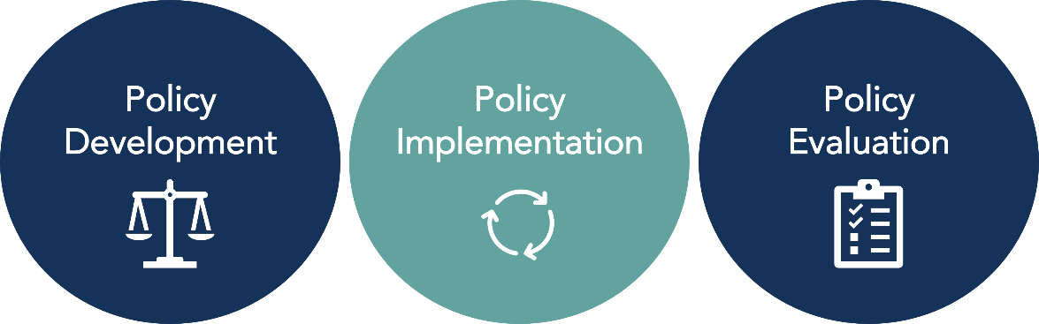

|  |
| --- |
| This form is for anyone interested in submitting a policy that was evidence-informed in its **Policy Implementation** to the [MCH Innovations Database](https://www.amchpinnovation.org/database/). Please complete all sections of this form unless otherwise indicated. To learn more about the Policy Track designations and for additional materials to support your submission, visit <https://www.amchpinnovation.org/submit-a-policy/>. If you are unsure if your practice is considered an example of evidence-informed policy development, use our [Policy Track Designation Criteria](mailto:Policy%20Track%20Designation%20Criteria) or contact AMCHP for support at [evidence@amchp.org](mailto:evidence@amchp.org).  **For submission support or for questions about this submission form or the submissions process,**  **email** [**evidence@amchp.org**](mailto:evidence@amchp.org)**.** |

|  |  |
| --- | --- |
| Contact Information | |
| **Name:** |  |
| **Organization:** |  |
| **Address:** |  |
| **Phone:** |  |
| **E-mail Address:** |  |

|  |  |
| --- | --- |
| **Submission Overview** | |
| **Name of Policy:** |  |
| **State in which policy is implemented:** |  |
| **Was this policy previously submitted to Innovation Station?** | Yes. Previously awarded policy category: _______________________  No |
| **Is this policy supported by Title V either by direct funding or staff time?** | Yes  No |

|  |  |
| --- | --- |
| Policy Overview | |
| **What issues does your policy address?**  *Select all that apply* | ☐ Access to Health Care/Insurance  Data Assessment/Evaluation  Economic Security  Health Care Financing  ☐ Family/Youth Engagement  ☐ Telehealth/Emergency Preparedness  ☐ Primary/Preventative Care  ☐ Health Equity  ☐ Health Screening/Promotion  ☐ Mental Health/Substance Use  ☐ Nutrition/Physical Activity  ☐ Injury Prevention/Hospitalization  ☐ Preconception/Reproductive Health  ☐ Service Coordination/Integration  ☐ Other: ______________________ |
| **What populations does your policy serve/impact?**  *Select all that apply* | ☐ Perinatal/Infant Health  ☐ Child Health  ☐ Children and Youth with Special Health Care Needs  ☐ Adolescent Health  ☐ Women’s/Maternal Health  ☐ Cross-cutting/ Life Course  ☐ Families/Consumers  ☐ Health Care Providers  ☐ Other: ______________________ |
| **Is it a Big P or little p Policy?** Learn more [here](https://www.youtube.com/watch?v=QgJ0NgOYcGY).*Select one* | “Big P” policy (e.g., community, state, or federal policies)  “Little p” policy (e.g., an organizational/agency-level policy)  Not sure |

|  |  |
| --- | --- |
| **How did you hear about this opportunity?** | |
| AMCHP Website  AMCHP Staff Person  AMCHP Social Media (Facebook, Twitter)  AMCHP Table at a Conference or Meeting | AMCHP Member Briefs/Regional Updates  AMCHP Infographic  AMCHP Pulse Issue  Shared by someone outside of AMCHP (please specify: ____________________________)  Other (please specify): |

|  |
| --- |
| **Policy Description**  As if you were explaining your policy to someone who has never heard of it before, provide a **high-level** description which also includes:   * The need your policy addresses * The key population it impacts * What it intends to accomplish * Any relevant background information such as the history behind the development of the policy and/or any principles or values that support it |
| **Response:** |

|  |
| --- |
| **One Sentence Summary**  Provide a one sentence overview of your policy. This sentence will be used for promotional purposes in the database. |
| **Response:** |

|  |
| --- |
| **Evidence-Informed Policy Implementation Submission Questions** |

**Instructions:** Please respond to all the questions in this section. All criteria for this category must be met to receive this policy designation. Provide evidence and cite sources as much as possible when answering each question.

|  |
| --- |
| 1. **Policy Goals**: What does the proposed policy aim to accomplish? Include both short-term and long-term goals when appropriate. |
| **Response:** |

|  |
| --- |
| 1. **Need:** What issue(s)/need(s) does this policy seek to address? What evidence supports this issue/need and how was it assessed/identified? |
| **Response:** |
| 1. **Health Equity:** Which racial/ethnic and other under-resourced groups are most advantaged by the issues the policy aims to address? Which groups are most disadvantaged? |
| **Response:** |

|  |
| --- |
| 1. **Health Equity:** How does the policy intend to address the root causes of disparities related to this issue experienced by advantaged and disadvantaged groups described in Question 3? |
| **Response:** |

|  |
| --- |
| 1. **Expected Outcomes:** What positive or equitable outcomes may result from this policy? What adverse or inequitable outcomes may result from the policy? |
| **Response:** |

|  |
| --- |
| 1. **Evidence:** What evidence was used to inform the implementation of this policy? Types of evidence may include, but are not limited to:  * Input, insights, and anecdotal evidence from affected populations and advocacy groups including community members, providers, health workers, staff, etc. * National/state/local surveillance or evaluation data * Research studies or experimental evidence |
| **Response:** |

|  |
| --- |
| 1. **Implementation Plan:** Describe the plan to implement/enact this policy, including resources needed such a funding, staffing needs, etc. What agencies, organizations, or other institutions are responsible for implementing this policy? |
| **Response:** |

|  |
| --- |
| 1. **Practicality:** Explain the feasibility of your policy implementation plan. Include cost and funding source considerations, staffing needs, and other potential resources associated with implementing the policy in your answer. |
| **Response:** |

|  |
| --- |
| 1. **Stakeholder Engagement:** Describe the key stakeholders that were involved in the policy implementation planning and execution, what their role was (e.g., key informant interviews to inform quality improvement, responsible party overseeing implementation, advisory board member, providing input through surveys, etc.), and the type/structure of the engagement (e.g., one time engagement, monthly engagement, community town hall, focus group, etc.). |

|  |  |  |
| --- | --- | --- |
| **Stakeholder** | **What was their role in the policy *implementation* process?** | **What was the structure/type of stakeholder engagement?** |
| *E.g. Local Health Department* | *Advised on the feasibility of the implementation plan and logistics* | *Bi-monthly meetings with leadership* |
|  |  |  |
|  |  |  |
|  |  |  |

|  |
| --- |
| 1. **Stakeholder Engagement:** Have members of the groups most affected by the policy been engaged in the policy implementation process? If so, how? |
| **Response:** |

|  |
| --- |
| 1. **Implementation Context:** Describe the political and social context in which the policy is/was implemented. |
| **Response:** |
| **a) Assets:** What assets and factors were beneficial in supporting the policy’s implementation (e.g., people or organizations that championed the policy, resources, public or political support, etc.)? |
| **Response:** |
| **b) Challenges:** What were the potential/experienced challenges to policy implementation, and how were they approached? |
| **Response:** |

|  |
| --- |
| 1. **Monitoring:** How were policy implementation efforts monitored to ensure they were being conducted as intended? For example, administrative reports and data tracking the number of providers receiving a training as stipulated in the policy implementation plan. |
| **Response:** |
| 1. **Evaluating Impact:** How was the policy’s success and resulting progress measured? For example, providers were surveyed after receiving the training and indicated an increase in confidence in providing care. |
| **Response:** |

|  |
| --- |
| 1. **Experienced Outcomes:** What positive or equitable outcomes have resulted from policy implementation so far? What adverse or inequitable outcomes have resulted? |
| **Response:** |

|  |
| --- |
| 1. **Continuous Quality Improvement:** Describe your process for conducting continuous quality improvements throughout policy implementation. What changes have been made to policy implementation based on the results of initial efforts and outcomes described in Questions 12, 13, and 14? |
| **Response:** |

|  |
| --- |
| 1. **Lessons Learned:** What lessons learned would you share with those interested in replicating this policy effort in the future? What if anything would you have changed about your approach? In addition to general lessons learned, also consider any specific to advancing health equity and stakeholder engagement. |
| **Response:** |

|  |
| --- |
| 1. **Continuous Quality Improvement:** Describe your process for conducting continuous quality improvements throughout policy implementation. What changes have been made to policy implementation based on the results of initial efforts and outcomes described in Questions 12, 13, and 14? |
| **Response:** |

|  |
| --- |
| 1. **Additional Resources:** Are there any additional resources (reports, tools, documents, articles, websites, etc.) that you would like to include in your policy handout published in our database? |
| **Response:** |

|  |
| --- |
| **Next Steps** |

|  |
| --- |
| Thank you for taking the time to share your policy with other practitioners and MCH policymakers so we can work towards improving the lives of MCH populations. Your submission will be carefully reviewed by a team of three reviewers with MCH policy expertise and experience. You will also be asked to complete a short survey on the submission form and submission process, so we can provide a better submission experience. You may also be contacted for follow-up if the committee has questions or needs additional information while reviewing your submission.  **If you have any questions, please contact us at** [**evidence@amchp.org**](mailto:evidence@amchp.org)**.** |

