MCH Innovations Database: Evidence-Informed Policy Track
Policy Evaluation Submission Form

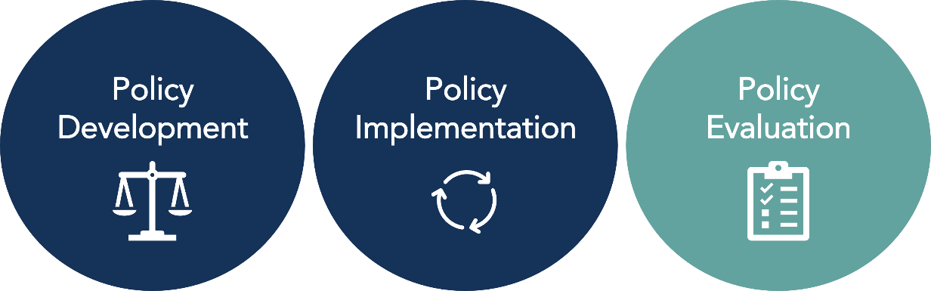

This form is for anyone interested in submitting a policy that was evidence-informed in its Policy Implementation to the MCH Innovations Database. Please complete all sections of this form unless otherwise indicated. To learn more about the Policy Track designations and for additional materials to support your submission, visit https://www.amchpinnovation.org/submit-a-policy/. If you are unsure if your practice is considered an example of evidence-informed policy development, use our Policy Track Designation Criteria or contact AMCHP for support at evidence@amchp.org.

For submission support or for questions about this submission form or the submissions process,
email evidence@amchp.org.

Contact Information
Name:
Organization:
Address:
Phone:
E-mail Address:

Submission Overview
Name of Policy:
State in which policy is implemented:
Was this policy previously submitted to Innovation Station? | ☐ Yes. Previously awarded policy category: _______________________  ☐ No
Is this policy supported by Title V either by direct funding or staff time? | ☐ Yes  ☐ No

Policy Overview
What issues does your policy address?  Select all that apply | ☐ Access to Health Care/Insurance  ☐ Data Assessment/Evaluation  ☐ Economic Security  ☐ Health Care Financing  ☐ Family/Youth Engagement  ☐ Telehealth/Emergency Preparedness  ☐ Primary/Preventative Care  ☐ Health Equity  ☐ Health Screening/Promotion  ☐ Mental Health/Substance Use  ☐ Nutrition/Physical Activity  ☐ Injury Prevention/Hospitalization  ☐ Preconception/Reproductive Health  ☐ Service Coordination/Integration  ☐ Other: ______________________
What populations does your policy serve/impact?  Select all that apply | ☐ Perinatal/Infant Health  ☐ Child Health  ☐ Children and Youth with Special Health Care Needs  ☐ Adolescent Health  ☐ Women’s/Maternal Health  ☐ Cross-cutting/ Life Course  ☐ Families/Consumers  ☐ Health Care Providers  ☐ Other: ______________________
Is it a Big P or little p Policy? Learn more here. Select one | ☐ “Big P” policy (e.g., community, state, or federal policies)  ☐ “Little p” policy (e.g., an organizational/agency-level policy)  ☐ Not sure

How did you hear about this opportunity?
☐ AMCHP Website  ☐ AMCHP Staff Person  ☐ AMCHP Social Media (Facebook, Twitter)  ☐ AMCHP Table at a Conference or Meeting | ☐ AMCHP Member Briefs/Regional Updates  ☐ AMCHP Infographic  ☐ AMCHP Pulse Issue  ☐ Shared by someone outside of AMCHP (please specify: ____________________________)  ☐ Other (please specify):

Policy Description
As if you were explaining your policy to someone who has never heard of it before, provide a high-level description which also includes:
- The need your policy addresses
- The key population it impacts
- What it intends to accomplish
- Any relevant background information such as the history behind the development of the policy and/or any principles or values that support it

Response:

One Sentence Summary
Provide a one sentence overview of your policy. This sentence will be used for promotional purposes in the database.
Response:

Evidence-Informed Policy Evaluation Submission Questions

Instructions: Please respond to all the questions in this section. All criteria for this category must be met to receive this policy designation. Provide evidence and cite sources as much as possible when answering each question.
- Policy Goals: What does the proposed policy aim to accomplish? Include both short-term and long-term goals when appropriate.

Response:

- Need: What issue(s)/need(s) does this policy seek to address? What evidence supports this issue/need and how was it assessed/identified?

Response:

- Health Equity: Which racial/ethnic and other under-resourced groups are most advantaged by the issues the policy aims to address? Which groups are most disadvantaged?

Response:

- Health Equity: How does the policy intend to address the root causes of disparities related to this issue experienced by advantaged and disadvantaged groups described in Question 3?

Response:

- Stakeholder Engagement: Describe the key stakeholders that were involved in the policy evaluation planning and execution, what their role was (e.g., developed evaluation questions/plan, provided input through surveys, key informant interviews, participated in analyzing and assessing data, etc.), and the type/structure of the engagement (e.g., one time engagement, monthly engagement, focus group, etc.).
Stakeholder | What was their role in the policy evaluation process? | What was the structure/type of stakeholder engagement?
E.g. Community practice partner | Helped to analyze qualitative data collected and develop themes | Monthly meetings with evaluation team

- Stakeholder Engagement: How was input and feedback from members of the groups most affected by the policy collected? Describe how this information was collected.

Response:

- How, if at all, was evaluation and other outcome data shared back with the groups most affected by the policy?
Response:

- Monitoring: If applicable, how were policy implementation efforts monitored to ensure they were being conducted as intended (include relevant process measures)? For example, administrative reports and data tracking the number of providers receiving a training as stipulated in the policy implementation plan.

Response:

- Evaluation Plan: How was the policy’s success and resulting progress evaluated? Include collection methods and impact measures used, and if data was collected from multiple sources and/or was disaggregated along demographic lines. Note: If your policy has been evaluated by external evaluators, you can summarize/cite any relevant methods used here.

Response:

- Necessary Resource: What resources (e.g., staffing needs, funding, technology, etc.) were needed to conduct this policy evaluation?

Response:

- Policy Impact: How effective was the policy in reaching the goals outlined in Question 1? Include relevant data to support your response.

Response:

- Equity Impact: Describe the impact that the policy has had on address inequities/disparities experienced by the racial/ethnic and other under-resourced groups described in Question 3. Include both positive and adverse outcomes, and support your response with data when possible.

Response:

- Unintended Outcomes: What unintended outcomes/consequences resulted from the policy? How were these measured?

Response:

- Lessons Learned: What lessons learned would you share with those interested in replicating this policy effort in the future? What if anything would you have changed about your approach? In addition to general lessons learned, also consider any specific to advancing health equity and stakeholder engagement.

Response:

- Additional Resources: Are there any additional resources (reports, tools, documents, articles, websites, etc.) that you would like to include in your policy handout published in our database?

Response:

Next Steps

Thank you for taking the time to share your policy with other practitioners and MCH policymakers so we can work towards improving the lives of MCH populations. Your submission will be carefully reviewed by a team of three reviewers with MCH policy expertise and experience. You will also be asked to complete a short survey on the submission form and submission process, so we can provide a better submission experience. You may also be contacted for follow-up if the committee has questions or needs additional information while reviewing your submission.
If you have any questions, please contact us at evidence@amchp.org.

