MCH Innovations Database: Evidence-Informed Policy Track
Policy Development Submission Form
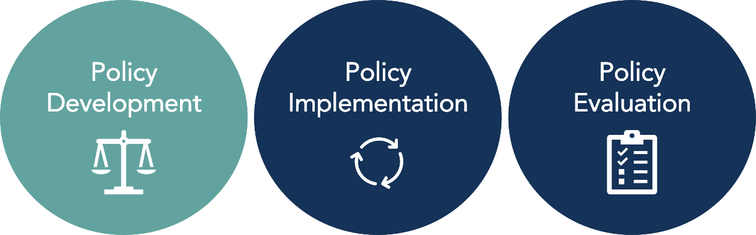

This form is for anyone interested in submitting a policy that was evidence-informed in its Policy Development to the MCH Innovations Database. Please complete all sections of this form unless otherwise indicated. To learn more about the Policy Track designations and for additional materials to support your submission, visit https://www.amchpinnovation.org/submit-a-policy/. If you are unsure if your practice is considered an example of evidence-informed policy development, use our Policy Track Designation Criteria or contact AMCHP for support at evidence@amchp.org.

For submission support or for questions about this submission form or the submissions process,
email evidence@amchp.org.

Contact Information
Name:
Organization:
Address:
Phone:
E-mail Address:

Submission Overview
Name of Policy:
State in which policy is implemented:
Was this policy previously submitted to Innovation Station? | ☐ Yes. Previously awarded policy category: _______________________  ☐ No
Is this policy supported by Title V either by direct funding or staff time? | ☐ Yes  ☐ No

Policy Overview
What issues does your policy address?  Select all that apply | ☐ Access to Health Care/Insurance  ☐ Data Assessment/Evaluation  ☐ Economic Security  ☐ Health Care Financing  ☐ Family/Youth Engagement  ☐ Telehealth/Emergency Preparedness  ☐ Primary/Preventative Care  ☐ Health Equity  ☐ Health Screening/Promotion  ☐ Mental Health/Substance Use  ☐ Nutrition/Physical Activity  ☐ Injury Prevention/Hospitalization  ☐ Preconception/Reproductive Health  ☐ Service Coordination/Integration  ☐ Other: ______________________
What populations does your policy serve/impact?  Select all that apply | ☐ Perinatal/Infant Health  ☐ Child Health  ☐ Children and Youth with Special Health Care Needs  ☐ Adolescent Health  ☐ Women’s/Maternal Health  ☐ Cross-cutting/ Life Course  ☐ Families/Consumers  ☐ Health Care Providers  ☐ Other: ______________________
Is it a Big P or little p Policy? Learn more here. Select one | ☐ “Big P” policy (e.g., community, state, or federal policies)  ☐ “Little p” policy (e.g., an organizational/agency-level policy)  ☐ Not sure

How did you hear about this opportunity?
☐ AMCHP Website  ☐ AMCHP Staff Person  ☐ AMCHP Social Media (Facebook, Twitter)  ☐ AMCHP Table at a Conference or Meeting | ☐ AMCHP Member Briefs/Regional Updates  ☐ AMCHP Infographic  ☐ AMCHP Pulse Issue  ☐ Shared by someone outside of AMCHP (please specify: ____________________________)  ☐ Other (please specify):

Policy Description
As if you were explaining your policy to someone who has never heard of it before, provide a high-level description which also includes:
- The need your policy addresses
- The key population it impacts
- What it intends to accomplish
- Any relevant background information such as the history behind the development of the policy and/or any principles or values that support it

Response:

One Sentence Summary
Provide a one sentence overview of your policy. This sentence will be used for promotional purposes in the database.
Response:

Evidence-Informed Policy Development Submission Questions

Instructions: Please respond to all the questions in this section. All criteria for this category must be met to receive this policy designation. Provide evidence and cite sources as much as possible when answering each question.
- Policy Goals: What does the proposed policy aim to accomplish? Include both short-term and long-term goals when appropriate.

Response:

- Need: What issue(s)/need(s) does this policy seek to address? What evidence supports this issue/need and how was it assessed/identified?

Response:

- Health Equity: Which racial/ethnic and other under-resourced groups are most advantaged by the issues the policy aims to address? Which groups are most disadvantaged?

Response:

- Health Equity: How does the policy intend to address the root causes of disparities related to this issue experienced by advantaged and disadvantaged groups described in Question 3?

Response:

- Expected Outcomes: What positive or equitable outcomes may result from this policy? What adverse or inequitable outcomes may result from the policy?

Response:

- Evidence: What evidence was used to inform the development of this policy? Types of evidence may include, but are not limited to:
- Input, insights, and anecdotal evidence from affected populations and advocacy groups including community members, providers, health workers, staff, etc.
- National/state/local surveillance or evaluation data
- Research studies or experimental evidence

Response:

- Stakeholder Engagement: Describe the key stakeholders that were involved in this policy development effort, what their role was, and the type/structure of the engagement (e.g., participated in monthly advisory board meetings, key informant interviews, drafted policy language, etc.).

Stakeholder | What was their role in the policy development process? | What was the structure/type of stakeholder engagement?

- Stakeholder Engagement: Have members of the groups most affected by the policy been engaged in the policy development process? If so, how?

Response:

- Champions: Describe any stakeholders who served as major champions of the policy that were critical to successful policy development.

Response:

- Social & Political Context: What was the political and/or social context in which the policy was developed? Describe factors that both facilitated policy development, and those that served as barriers.

Response:

- Lessons Learned: What lessons learned would you share with those interested in replicating this policy effort in the future? What if anything would you have changed about your approach? In addition to general lessons learned, also consider any specific to advancing health equity and stakeholder engagement.

Response:

a) Funding: Describe the funding needed both to develop this policy, and if applicable funding needed to implement the policy, including funding sources.
Response:

- Additional Resources: Are there any additional resources (reports, tools, documents, articles, websites, etc.) that you would like to include in your policy handout published in our database?

Response:

Next Steps

Thank you for taking the time to share your policy with other practitioners and MCH policymakers so we can work towards improving the lives of MCH populations. Your submission will be carefully reviewed by a team of three reviewers with MCH policy expertise and experience. You will also be asked to complete a short survey on the submission form and submission process, so we can provide a better submission experience. You may also be contacted for follow-up if the committee has questions or needs additional information while reviewing your submission.
If you have any questions, please contact us at evidence@amchp.org.

